

**Department of Software Engineering**

**APPLIED PHYSICS (LAB)**

# Laser Security Alarm System

**Submitted By**

|  |  |
| --- | --- |
| **Muhammad Rizwan**  **Seemab Asghar**  **Huzaifa Ahmed** | **(02-131222-018)**  **(02-131222-047)**  **(02-131222-074)** |

**BSE – 1 (B)**

**FALL 2022**

**Submitted To**

## Ma’am Mubashrah Zaib

**Table of Contents**

1. **Abstract ..................................................................................................... PG # 3**
2. **Introduction ......................................................................................................... 3**
3. **Components .......................................................................................................... 4**
4. **Circuit Diagram .................................................................................................. 4**
5. **Working ................................................................................................................ 5**
6. **Results and Discussions ....................................................................................... 5**
7. **Conclusion ........................................................................................................... 5**
8. **Project Summary ................................................................................................. 5**
9. **Project Pictures ………………………………………………………………... 6-7**
10. **References............................................................................................................. 8**

1. **ABSTRACT:**

This project deals with the model of laser security alarm system design. It is a type of security system that provide security to homes, offices, lockers etc. There is a laser diode that will shoot out from one area and will reflect off a series of mirrors across your yard and beam will continuously skrikes over the LDR sensor. When any person cross the path, it inhibits laser to reach the LDR. Then, it activates the buzzer.

1. **INTRODUCTION:**

Lasers play many roles in our everyday lives, from optical storage (CDs and DVDs) to metal cutting to tattoo and hair removal. Not everyone knows that laser is actually an acronym. (Take guesses from students.) Laser stands for light amplification by stimulated emission of radiation.

Need of security is the basic necessity of any individual. The feeling that we are safe and everything around us is all right is imperative for a peaceful living. But in this unsafe world .When crime, terror and threats are on their peak, how can one attain that sense of security? Here, laser security system provides us with a solution and for this reason more and more people are installing them in order to stay safe and secure. Various electronic security systems can be used at home and other important working places for security and safety purposes.

Laser Security alarm is a device used for security purposes. It has a wide application in fields of security and defense starting from the security of simple house hold material to a very high valued material of an organization. They once used to be expensive solutions for security needs.

Laser light travels in a straight line. For instance, to protect the front of the yard, putting the laser at one comer and the detector at the other corner would do the job. That's not a very practical configuration, though. More typically, if it is needed to protect the perimeter of a room, or at least the enhances. So laser security systems start with a laser pointing to a small mirror. The first mirror is angled to direct the beam to a second small mirror, and so on until the final mirror directs the beam to the detector. If the beam is interrupted anywhere between the laser and the detector, the electronics will put the warning signal.

1. **COMPONENTS:**

BC547 Transistor.

LDR

2.2 K Ohm Resistor.

Breadboard.

5mm LED Light.

Wires.

9 Volt Battery.

Buzzer.

Switch.

Laser Pointer.

Mirrors.

1. **CIRCUIT DIAGRAM:**

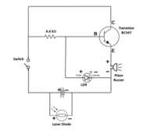

1. **WORKING:** 
   * + - First of all, connect the BC547 Transistor on breadboard.
       - Now connect the LDR with the Base and Emitter of BC547 Transistor.
       - Then, connect the 2.2k ohm resistor with the Base of BC547 Transistor and any blank space on breadboard.
       - Now, connect the negative side of 5mm LED Light with the LDR and positive side with the
       - Emitter of BC547 Transistor.
       - Connect the buzzer as the same way as 5mm LED Light is connected.
       - Also, connect the switch.
       - Now, connect the 9 volt battery.
       - Also fix the Laser Light Pointer.

1. **RESULTS:**

Firstly the Laser Light goes on 1st mirror, then reflect on 2nd mirror and then on 3rd mirror, from 3rd mirror it goes on LDR.

This system is based on the interruption of laser beam. If somehow the laser path is broken the alarm will be generated for few seconds.

Any unknown person crossing this invisible boundary triggers the alarm in system making us aware of the unknown person. So that we can take the required steps to protect ourselves

1. **CONCLUSION:**

Lasers have a strong beam width & can be focused on the perfect target. One can be safe in case of harmful effects on the body by using laser security system. Not only so. This cheap security system can be used in different commercial buildings mainly banks. Laser security system is ultimately a high tech security system that is both easily available and has a low baget providing protection in full security. It is nothing but a manually switch dependent sensor and a basic alarm unit. This alarm unit sounds a loud siren and also signals by lighting.

1. **PROJECT SUMMARY:**

The laser security alarm circuit utilizes laser sensors for intruder detection. When any person or object crossover the laser line the security alarm will ringing and also the focus light will "on" to focus the entrance of unauthorized person. LASER-Ray goes through long distance without scattering effect and the Ray is almost invisible. Only the radiation point and incident point is visible. So by this security project we can make an invisible boundary of a sensitive area.

1. **PROJECT PICTURES:**

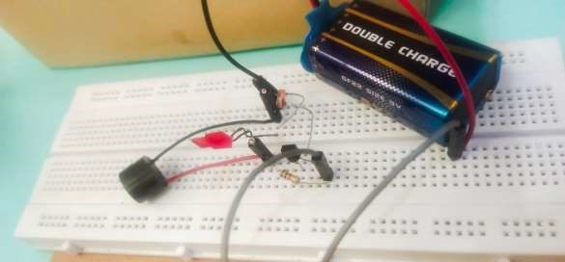

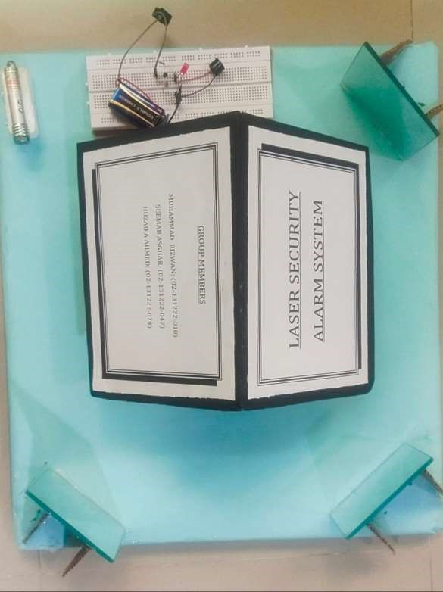

1. **References:** 
   * + - [**https://www.youtube.com/watch?v=n-Phvv4F59c&t=379s**](https://www.youtube.com/watch?v=n-Phvv4F59c&t=379s)
       - [**https://www.youtube.com/watch?v=1EH_fxebXEU**](https://www.youtube.com/watch?v=1EH_fxebXEU)